Kol Simcha Torah Gazette
For parsha bo 5785
Volume 9 Issue 19 (Whole #433) 3 Shevat 5785/ February 1, 2025
Printed L’illuy nishmas Nechama bas R’ Noach, a”h
For a free subscription, please forward your request to keren18@juno.com
Past emails can be found on the website ShabbosStories.com under Brooklyn Torah Gazette

With Mengele in Auschwitz
By Rabbi Shraga Simmons

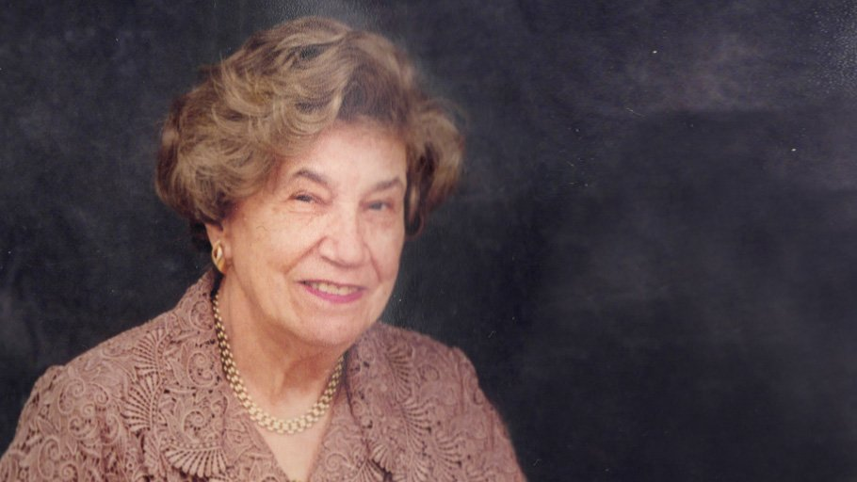

In 1944, Yantu Weisz was 35 years old when the Nazis entered the Hungarian town of Mezokovesd and rounded up the Jewish community. Yantu was herded – together with her sister and mother – onto a cattle car. The train chugged toward Auschwitz, with inhuman conditions of no food, water, or facilities.
Days later, the train pulled its weary and dispirited cargo through the notorious red brick gate. As the cattle car door opened, the first thing Yantu saw was a pair of shiny black boots. They belonged to an immaculately dressed soldier with a riding whip – the bespectacled Angel of Death, Yosef Mengele. Yantu and the others were quickly pushed into line where Mengele pointed his whip – to the right for slave labor, to the left for gas chambers and crematoria.
Though upset about being childless, that saved her life.
It was clear that Yantu's more elderly mother was destined for death, and the two sisters decided not to abandon her. In those perilous moments they were uncertain which sister will be spared, and which will accompany their mother to the gas chamber.
Because Yantu’s sister had a young child with her, she was automatically sent to the left with their mother.
Yantu was married for 10 years and childless. Though she’d been upset about not having children, it saved her life.
Yet prior to the fateful deportation, Yantu had become pregnant. As she stood in Mengele’s line, instructions were given for all pregnant women to step forward and “receive better care.” As Yantu was about to comply, another woman alerted her not to reveal the pregnancy: Being caught pregnant in Auschwitz meant certain death.
One night, after having been in Auschwitz for a few weeks, Yantu became very weak with abdominal pains. She went to the latrine and the baby slipped out.
Afterwards, Yantu received assistance from a Jewish nurse – perhaps the legendary Dr. Gisella Perl, a Hungarian prisoner in Auschwitz who was ordered to inform Dr. Mengele of any pregnant women in the camp. His evil intent: to perform cruel and excruciating “medical experiments.”
Yet Dr. Perl bravely defied these cruel orders. She would warn any pregnant woman of the life-threatening situation. Then, using no tools, anesthesia, bandages or antibiotics, Dr. Perl often saved the pregnant woman’s life – lovingly and compassionately performing an abortion… in the middle of the night… on the dirty barrack bunks.
(Dr. Perl survived the war and moved to New York City, where she specialized in infertility, making it her mission to bring life into the world, as chronicled in her autobiography, "I Was a Doctor in Auschwitz.")
Following the miscarriage, Yantu felt very sick and – against everyone’s advice – checked into the concentration camp “hospital.” There, Mengele would visit daily, walk around the beds, and point to those to be taken out and gassed. Miraculously, he never pointed at Yantu.
One evening, one of Yantu’s friends came to the hospital and told her to get up, as a transport was taking them to a better place. Yantu was very weak and told her friend to go on without her.
Not one person from that transport survived.
In the course of six months – first in Auschwitz, then in a munitions factory making bullets – Yantu endured the most horrific conditions – a Nazi tactic to make the Jews “subhuman.” Prisoners were given food only once daily – one small piece of bread and something to drink in the evening. Once, Yantu decided to save her bread for the morning as a way to have more strength during the day. She hid the bread under her head and in the morning it was gone – stolen! From then on, Yantu ate her bread immediately.

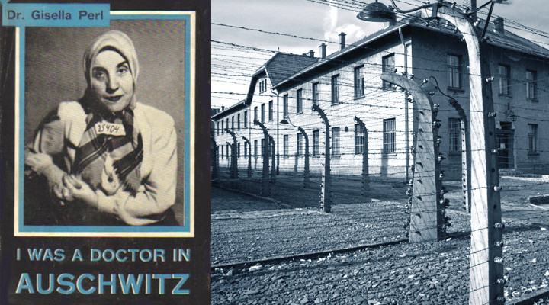

Whenever Yantu spoke about her Holocaust experience, she always said that no story, movie or book could adequately convey the sheer horror they endured.

Liberation and the New World
One day, all the Nazi guards ran away. Liberation! The war was over and Yantu survived due to physical strength and a tremendous determination to live. With humility, however, she did not regard her survival as commendable, saying that the finer, more genteel people died; only the tougher ones managed to survive.
Yantu's husband Azriel Chaim, despite suffering from diabetes, also survived the war, however in a weakened condition from which he never fully recovered. (When he died at age 67, the doctors said he was like 85.)
After the war, Yantu and Azriel Chaim returned to their hometown in Hungary, to see what remained. One of Yantu's sisters had gone into hiding in Budapest and survived. Additionally, two of Yantu's three brothers survived the slave labor camps.
Following the war, Yantu had difficulty getting pregnant again and suffered a few miscarriages – complications of her experience in Auschwitz. She was well into her 40s when two children were born, whom she referred to as "miracles." Her son, Rabbi Noson Weisz, is today a senior lecturer at Yeshivat Aish HaTorah in Jerusalem. Her daughter, Annie, lives in New York.
For a few years, the Weisz family enjoyed the thriving Jewish community in Budapest – he with a government job and she as a seamstress. Yet when Hungary became a satellite of the communist Soviet Union, life became difficult. The open practice of religion was not allowed, and children were required to attend school on Shabbat.
The Weisz family wanted to leave – but the border was closed.
With the Hungarian revolution of 1956, the border opened again and Yantu insisted that they leave – so her children could grow up as proud Jews, not Communists. At the first opportunity, they escaped to Vienna, where they applied for exit visas to Israel, USA and Canada. The visa for Canada came first, so they immigrated to Toronto.


Rabbi Noson Weisz teaching at Yeshivat Aish HaTorah in Jerusalem.

Within six months, the ever-adaptable Yantu was fluent in English and had reestablished her career as a successful, high-end dress designer who made wedding and evening gowns.
Independent and Strong
Yantu lived by herself in Toronto until age 102, working as a seamstress and remaining independent the entire time. She described work as “the best medicine for whatever bothers you.”

Her Independence Was More
Important to Her Than Anything
"Her independence was more important to her than anything," says her son, Rabbi Weisz. “Her eyesight and mental faculties remained sharp until the very end.”
Yantu wanted her son to be a doctor, but he wanted to be a rabbi. So concurrent with yeshiva studies, he attended University of Toronto night school, earning degrees in microbiology and in law. “My mother then wanted me to go to graduate school, so I consulted with the great Rabbi Moshe Feinstein, who said: 'She is a Holocaust survivor. Do what she asks,’” says Rabbi Weisz, who earned a Masters in Political Science.
Though the children never knew their grandmother who perished that first day in Auschwitz, she was a strong presence in their life. "My mother always followed in my grandmother’s ways and quoted her,” says Rabbi Weisz. “For example, my grandmother was a seamstress and said: 'I supported my family with my sewing machine, so I want to be buried with a coffin made of my sewing machine.' My mother was also a seamstress and the memories of her mother were never far."

A Legacy of Courage and Goodness
Yantu passed away in April 2018 at age 109, bequeathing to 70 descendants a legacy of courage and goodness.
"The Talmud says that someone who lives a long life can usually attribute it to a specific merit," says Rabbi Weisz. "My mother's outstanding trait was that if she could avoid it, she never took anything from anybody.”
When her son became engaged to a woman from a prominent, wealthy family, Yantu insisted on paying for half the wedding expenses. This was to the other family’s chagrin, as they could not countenance accepting money from a survivor who was eking out a living. The bride's parents had to come up with creative ways to assume as many expenses as possible since Yantu was always averse to "taking."
"If someone asked for tzedakah, she always gave. Even when people owed her money, she never asked for it back,” says Rabbi Weisz. “She always gave and never took. There aren't people like this around anymore."

Reprinted from the current website of aish.com

Rav Avigdor Miller on the
Purpose of Death and Disease
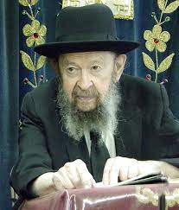
QUESTION: If the world was created for chessed, why do we have sickness and germs and disease in the world?
ANSWER: And the answer is, let’s take a mashal of forest fires. Forest fires are a great loss. They burn down sometimes millions of dollars-worth of lumber. But it’s been discovered that forest fires are a very big benefit. Because in the course of time some trees become nests of pollution; various germs settle in the trees and they can be a source of infection for other trees. When a forest fire comes, it burns down all the trees and the forest starts growing all over again new healthy trees.
Now the question, why is there disease, is the same question, why is there death in the world? That’s a good question. Why is there death in the world? The answer is, if there wasn’t any death, then the young people would never get a chance. Always the old people would be in charge. Let’s say a young man wants to become a rosh yeshiva, now he’s a young fellow of 75, but his rebbe of 150 is still there. So, what can the younger generations do?
So Hakodosh Boruch Hu makes place. You had your chance. You should have done the best you can in the time that was allotted to you and now go onto your reward in the next world and give somebody else a chance.
Now one of the ways of getting people out of this world are diseases. If a man was healthy to his last minute – let’s say an old rebbe, he’s 175 now. He’s perfectly healthy, he’s not lacking anything. But Hashem says, “Your time is up,” so he drops dead all of a sudden, it’s a tragedy. To drop dead all of a sudden, it’s a tragedy of tragedies. Oy vey!
So, Hashem doesn’t do that. He does it little by little. First he makes him sick a little bit. Then little by little, so he eases him out. By the time he’s ready to leave the world, he’s happy to leave the world. And his relatives are also happy. He was a big burden on them. They’re happy to get rid of him. They don’t say that, but they’re happy to get rid of it.
And so Hakodosh Boruch Hu eases people out of the world. And you have to have germs. Germs do the job. Without germs, a person would be healthy and strong till his last minute and it would be a terrible tragedy. It would be the same tragedy as if a boy chalilah died. If a rebbe would die in the middle of his healthy years, it would be a tragedy. And so, germs are sent to help people, little by little, gradually to leave the world.

Reprinted from a recent email of Toras Avigdor, - (based on Tape #E-46 – January 1996)

Thoughts that Count
for Our Parsha

They did not see one another, nor did any rise from his place (Ex. 10:23)
The worst kind of darkness is the unwillingness to see another's distress and extend a helping hand. The end result of such indifference is that the "blind" person himself becomes mired in place, unable to rise... (Chidushei HaRim)

Let every man borrow from his neighbor, and every woman from her neighbor...and G-d gave the people favor in the sight of the Egyptians (Ex. 11:2-3)
When Jews act kindly and help each other out in times of need, G-d grants them favor even in the eyes of their enemies, for their actions arouse an abundance of loving-kindness from Above. (Toldot Adam)

Reprinted from Parshat Bo 5762/2002 edition of L’Chaim

The Second Miracle of the Plagues of Darkness and the Redemption
of the Sparks of Holiness
From the Teachings of the Lubavitcher Rebbe
Rabbi Menachem Mendel Schneerson, Zt”l



The ninth plague to befall Egypt was the plague of darkness, as described in this week's Torah portion, Bo: "They did not see one another, nor did any rise from his place for three days; but all the people of Israel had light in their dwellings."

The Midrash explains that the plague of darkness entailed two separate miracles: a supernatural darkness that enshrouded the Egyptians and "glued" them in place for three days, and a miraculous light that enabled the Jewish people to see.

By the light of this illumination, the Jews were able to enter the homes of the Egyptians and locate the treasures that were hidden there. Later, when the time came for the Jews to leave Egypt and G-d commanded them to borrow "vessels of silver and vessels of gold," the Egyptians were unable to refuse their requests, as the Jews knew exactly where everything was hidden.

This second miracle came about in order to fulfill G-d's promise to Abraham years before, when He told him that his descendents would be enslaved in Egypt: "And afterwards they will go out with great wealth." In the merit of this light, the Jews were able to "empty" Egypt of its treasures, in fulfillment of G-d's command, "And you shall plunder the Egyptians."

Chasidic philosophy explains that the material wealth the Jews took with them from Egypt was an expression of the spiritual wealth they derived - the tremendous number of "holy sparks" that had fallen to the morally depraved country. By going through the Egyptian exile, the Jewish people were able to redeem these sparks and restore them to their Divine source.

The fact that G-d performed a special miracle to facilitate the process demonstrates that He actively helps us in our service of "redeeming the sparks." G-d gives every Jew a "special light" that enables him to penetrate the "depths of Egypt" and withdraw the spiritual "wealth" that needs redemption.

Even now, in our present exile, the Jewish people are occupied with redeeming "sparks of holiness." Whenever a Jew utilizes a physical object for its Divine purpose, he elevates the sparks it contains and restores them to their original source.

Moreover, G-d continues to perform miracles that help us in our Divine mission. For even though we are still in a time when "darkness shall cover the earth, and thick darkness the people," with the help of this special light, every Jew can prepare himself, with joy and gladness of heart, for the time when "the L-rd shall shine upon you": the full and complete Redemption with Moshiach.

Reprinted from Parshat Bo 5762/2002 edition of L’Chaim, a publication of the Lubavitcher Youth Organization. Adapted from Volume 31 of Likutei Sichot

******************************************************************
And the L-rd struck all the firstborn in the land of Egypt (Ex. 12:29)
Comments Rashi: "Whenever the Torah states 'and the L-rd,' it refers to G-d and His heavenly court." When it comes to meting out punishment, G-d gives the decision over to the heavenly angels, who do not know the thoughts of man. (A Jew is not punished for negative thoughts, as it states, "A bad thought is not considered part of deed.") By contrast, when it comes to reward, G-d does not consult with His heavenly court, as "a good thought is considered part of deed," and only G-d knows our thoughts and intentions. (Nezer HaKodesh)

Reprinted from Parshat Bo 5762/2002 edition of L’Chaim
Rabbi Berel Wein on
Parshat Bo 5785



But we are all aware that this parsha only represents the beginning of a long and arduous story plot that has yet to reach its eventual happy conclusion. The new situation of freedom from actual physical slavery, as heady and triumphant as it is, presents only new challenges.
Life itself resembles a series of doors. Upon successfully opening one door, it is discovered that there are now different doors – even a series of doors - behind the original one. The challenges of being a free person are, to a great extent, even more challenging than those of being locked into servitude.
We are witness to the Torah’s recording of forty years in the desert until there arises a generation of Jews that is able to meet the challenge of establishing itself as a functioning national entity in its promised land of Israel. The word “bo” which serves as the headline of this week’s parsha indicates “coming” – a beginning - not a sense of finality and end.
The Torah wishes to indicate to us that “the arrows are always yet ahead of us” to find and deal with. And there are many miracles involved in being freed from slavery but the road from there to true independence and accomplishment requires hard work, human persistence and unflagging spirit and high morale. In our world of changing eras and bewildering uncertainties we can only reflect upon the enormous challenges facing us. The Diaspora, as Jewry knew it to be for many centuries on end, is no longer. The tremendous accomplishment of the creation of the State of Israel and its sustenance is behind us.
This process was fraught with many plagues and concurrent miracles. The faith of Israel has sustained us through these times of ordeal and difficulties. But now there are new and perhaps even more difficult challenges that face us. The task of nation-building is a long and arduous one, not given to easy solutions and pat sloganeering.
It is measured not in years but in decades - if not even in centuries. It requires faith and tenacity and a long view of things. That is what G-d meant when he told Moshe at the beginning of the redemption process that Israel would accept the Torah at Sinai and that He would eventually bring them to the land that he promised to their forefathers. Why bother Moshe with those promises when the people are under the lash of slavery?
But G-d informs Moshe that freedom from slavery is only the beginning of the story, not its culmination. Our modern story of Israel does not end in 1948 or 1967. The realization of this stark truth can fire us to greater understanding and firmer belief and behavior in the justice of our cause and its eventual triumph.

Reprinted from the current website of rabbiwein.com
15 Facts You Should Know About Moses’ Staff
By Yehuda Altein


Art by Sefira Lightstone
Moses’ staff is one of the most iconic symbols in the story of the Exodus, used to unleash the plagues, split the sea, and perform other miraculous feats. Read on for 15 facts about this wondrous divine artifact and its storied history.

1. It Was Over 2,000 Years Old When Moses Used It
The staff was ancient even in Moses’ times. According to tradition, it was one of the 10 miraculous phenomena G-d created in the twilight hour, as Shabbat entered on the sixth day of Creation.¹

2. Some Say It Was Made of Sapphire
One tradition says the staff was crafted from sapphire, weighing forty se’ah (a Talmudic measurement).² Others relate it was made from the wood of the Tree of Knowledge.³

3. It Had Hebrew Inscriptions
Far from being an ordinary stick, Moses’ staff was inscribed with several powerful Hebrew words. These included G-d’s ineffable four-letter name, as well as detzach adash b’achav—an acronym for the ten plagues, and the names of the Patriarchs, Matriarchs, and the Twelve Tribes.⁴

4. It First Belonged to Adam
According to the Midrash, the staff had an impressive provenance, beginning with Adam, the first human. It was passed down to Enoch, then to Noah, Shem, Abraham, Isaac, and Jacob.⁵ Jacob carried it when he crossed the Jordan River on his return from Laban’s house⁶ and later passed it to his son Joseph.⁷ Others say it was (also) used by Jacob’s son Judah.⁸

5. It Ended Up in Jethro’s Garden
After Joseph’s death, the Egyptians looted his household and the staff made its way to Pharaoh’s palace. Jethro, one of Pharaoh’s advisors, discovered it and took it with him to Midian, where he planted it in his garden. No one could pull it out—until Moses came along and removed it, marking him as someone destined for greatness.⁹

6. It Turned Into a Snake—Twice!
The staff’s miraculous nature first appears in the Torah when G-d gives Moses three signs to prove his mission to the Israelites. The first sign was that the staff would transform into a snake when tossed to the ground and then back into a staff when Moses picked it up.¹⁰
Later, Aaron performed the same miracle before Pharaoh. When Pharaoh’s sorcerers replicated it, Aaron’s staff swallowed their staffs—a symbol of G-d’s absolute power over the forces of impurity.¹¹

7. It Was Central to the Ten Plagues
Moses’ staff was used to bring six of the ten plagues upon Egypt. Aaron wielded it for the first three, striking the Nile to turn it to blood, summoning frogs, and producing lice.¹² Moses used it for hail, locusts, and darkness.¹³

8. Some Say Aaron Used His Own Staff
There’s some debate about which staff Aaron used. Some commentators say it was Moses’ staff, given to Aaron for those wonders he performed,¹⁴ while others suggest that Aaron used his own staff.¹⁵

9. It Was Used to Split the Sea
Perhaps the most famous use of Moses’ staff was at the Sea of Reeds. With Pharaoh’s army closing in, Moses stretched the staff over the water, splitting the sea so the Israelites could cross on dry land.¹⁶ Once they had crossed, he used it again to bring the waters crashing back down on the pursuing Egyptians.¹⁷
According to another understanding (based on a close analysis of the verses), the staff was not used for this miracle. Instead, G-d instructed Moses to set aside the staff at this time to emphasize that it was G-d’s power, not the staff, that performed the wonders.¹⁸

10. Moses Held It During the Battle With Amalek
When the Amalekites attacked the Israelites in the desert, Moses stood on a hill holding his hands aloft. According to some, he was also holding his staff. As long as the staff was raised, the Israelites prevailed in battle.¹⁹

11. It Brought Forth Water From a Rock
Twice during their time in the desert, the Israelites faced a water crisis. On both occasions, Moses used the staff to bring forth water from a rock.²⁰ The second time, some believe he used a different staff—the one that miraculously sprouted almonds in the Korah episode.²¹

12. It Was Passed Down to King David
The staff didn’t disappear after Moses’ passing. It was passed down through the generations and eventually reached King David, who carried it when battling Goliath. After his reign, it remained with the kings of Judah until the destruction of the Holy Temple.²²

13. It Was Hidden Before the Temple’s Destruction
Before the Temple was destroyed, the staff was hidden, along with other sacred objects. According to one tradition, it resides in the same secret place as the Holy Ark and other treasures of the Tabernacle.²³
14. It Inspired the Name of a Book
Rabbi Moshe Mos, a 16th-century Polish scholar and disciple of Rabbi Shlomo Luria, wrote a halachic compendium called Matteh Moshe (“Staff of Moses”). In the introduction, he wrote, “When I arrive in the Next World and they ask me what I have to show for myself, I will tell them I brought a staff, just like Moses.”
15. It Will Return in the Ultimate Redemption
According to tradition, Moses’ staff will reappear during the Final Redemption and be given to Moshiach.²⁴ May we see this incredible event very soon!
Footnotes
1. Ethics of the Fathers 5:6.
2. Shemot Rabbah 8:3. Rashi to Exodus 17:6.
3. See Zohar Chadash, Beshalach 38b. Yalkut Reuveini, Chukat. Seforno to Exodus 4:17.
4. Targum Yonatan to Exodus 14:21. Shemot Rabbah 8:3.
5. Pirkei D’Rabbi Eliezer 40.
6. Genesis 32:11. Yalkut Shimoni, Chukat 763.
7. Pirkei D’Rabbi Eliezer 40.
8. Yalkut Shimoni, Chukat 763. See Genesis 38:18.
9. Pirkei D’Rabbi Eliezer 40.
10. Exodus 4:1–5.
11. Exodus 7:8–13.
12.Exodus 7:19–20. Exodus 8:1–2. Exodus 8:12–13.
13. Exodus 9:22–23. Exodus 10:12–13. Exodus 10:21–22 (see Ibn Ezra ad loc.).
14. Ibn Ezra to Exodus 7:9.
15. Zohar II 28a. Abarbanel to Exodus 7:14–25.
16. Exodus 14:21.
17. Exodus 14:26–27.
18. Midrash cited in Kli Yakar to Exodus 14:16.
19. Exodus 17:8–13. See Rashbam to Exodus 17:11.
20. Exodus 17:1–7. Numbers 20:2–11.
21. Rashbam and Chizkuni to Numbers ad loc. See Numbers 17:16–26.
22. Yalkut Shimoni, Chukat 763.
23. See Midrash Sechel Tov, Shemot 4:17.
24. Yalkut Shimoni, Chukat 763.

Reprinted from the current website of Chabad.Org

